# **Lab 5:**

Name:M.Areeb Bhatti

Class:IT-3A

ID:BIT-23F-027

Q1.Print Numbers with Loops: Write a program that uses a loop to print numbers from 1 to 10.

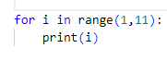 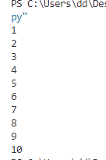

Q2.Calculate the Sum of Numbers: Write a function that calculates the sum of all numbers up to a given number using a loop.

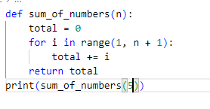 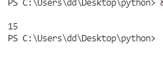

Q3:Display a Star Pattern: Write code using loops and nested loops to create star pattern(discussed previously).

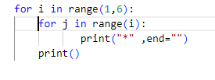 n 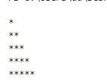

Q4.Find Even Numbers in a List: Write a function that takes a list of numbers and prints only the even numbers.

